FOR IMMEDIATE RELEASE | EMAIL: info@spaceupeurope.eu
URL: www.spaceupeurope.eu
TWITTER: @spaceupproject

Participate in the Space Academy, accelerate your start-up on the road to maturity!
We are pleased to announce that the first Space Academy, will be held on the 3-4 June 2019 in Helsinki, Finland, just before the Arctic15 conference coinciding and in collaboration with the EBAN Annual Congress.
More information and details will be released via the SpaceUp website, which is where companies interested in participating can apply. Also signup here to the newsletter to get notified of ongoing updates and news.
The Space Academy is a two-day event for European space-tech entrepreneurs to accelerate their business.
Day 1: An intense day where entrepreneurs can improve their skills and get insights from experts on various topics, with six parallel workshops as well as one-to-one coachings and roundtable meetings.
Day 2: Panels and keynote sessions with space actors and investors, involving regional industry for cross-clustering. Pitching from 10 start-up companies (coached by SpaceUp experts) to this audience for high-level feedback.
All accepted entrepreneurs are welcome to join the Space Academy workshops during the first day on six great topics by prominent experts:
- Investment readiness and relationships, how to be trusted by investors and get funded;
- Crowdfunding (the various kinds - reward-based, equity-based, lending), how to maximize your impact with the right campaign;
- Hot trends, artificial intelligence and robotics, how new advanced technologies can shape your business;
- Business models, how to fine tune your business and make it even more effective;
- European funds for young SMEs, how to find the right funding opportunity in the ocean of the European initiatives;
- European Space ecosystem, how to connect with international space institutions and corporates, and apply to ESA Invitation to Tender (ESA ITT).
In addition, 10 selected companies will be entitled to receive high-level services for free:
- One-to-one meetings with investors and matter experts;
- Credit Passport (International creditworthiness certificate);
- Feasibility study on EU public funding;
- Business model analysis;
- Consultancy on HR matters;
- Intellectual property right analysis.

Who can apply for the high-level services
- Companies post seed stage now looking for investment in either a pre-Series A (possibly angels/corporates), or a VC Series A round (companies must be post friends and family and have already received seed investment from accredited investors)
- Strong team and established business now scaling
- Only European companies, that were incorporated no later than 5 years ago (exceptions made for companies in certain industries)
- Companies adopting at least one space technology and/or working with Copernicus/Galileo/EGNOS data

What is offered to the 10 selected companies
- Up to €400 reimbursement for eligible travel and hotel costs.
- 3-minute pitching slot
- Access to EBAN Networking App
- Access to all other workshops and sessions of the EBAN Congress
- A chance to compete for special recognition awards and prizes
- Profile listed in EBAN congress booklet(s) and website
- Pre-event visibility in promotional campaigns

Date
June 3-4, 2019

Location
Helsinki, Finland (venue TBC)

How to participate
Apply at: www.spaceupeurope.eu

What is SpaceUp
SpaceUp is a project financed by the EU Framework programme for Research and Innovation (Horizon 2020). The overall objective of SpaceUp is to contribute at a European level to the safeguarding and further development of a competitive and entrepreneurial space industry.
Throughout the project lifetime six Space Academies will take place in various locations in Europe, networking new space tech entrepreneurs with potential partners in Finance, Business, Space Clusters and Science Parks, plunging Start-ups into a genuinely European Space ecosystem.

What is EBAN Congress
The EBAN Annual Congress is a two-day event attended by more than 300 representatives of the early stage financing industry, venture capitals and entrepreneurs from all over the world. The Space Academy will take place in parallel over these two days with shared opportunities and workshops. An amazing opportunity for learning, networking and building new business relationships! www.ebanhelsinki2019.com.

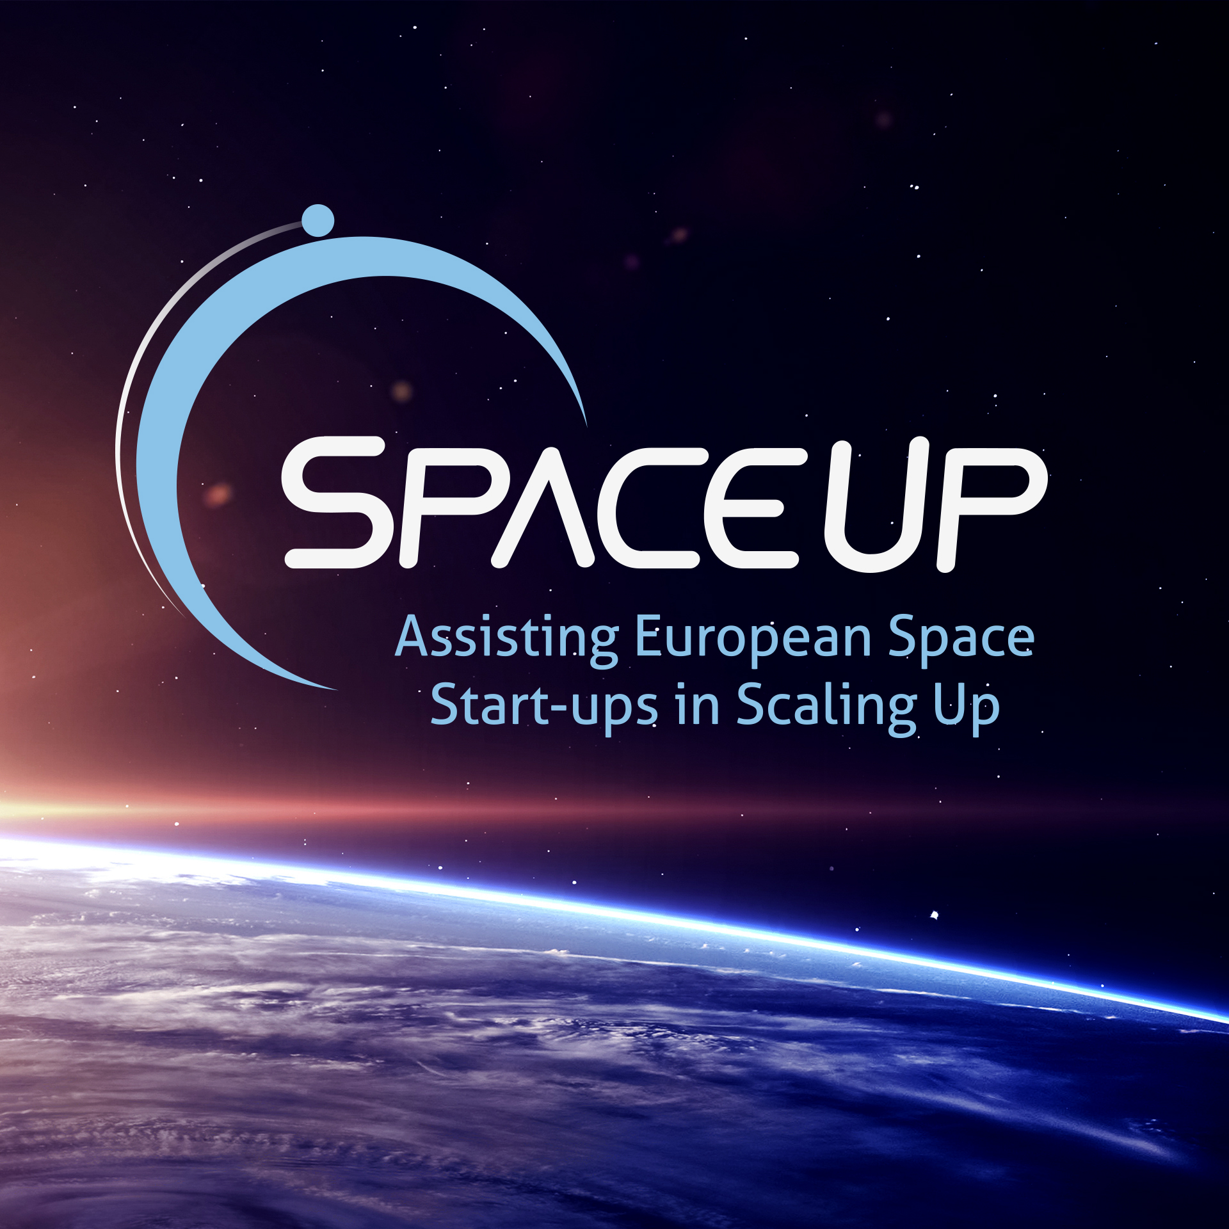
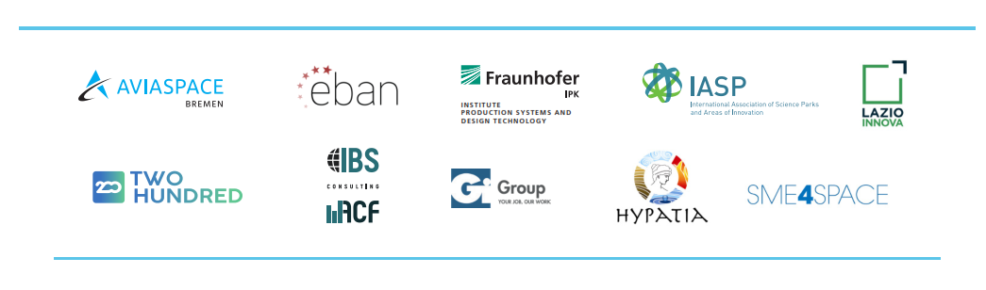
Project consortium

Image:

